
Name of Report: Decision Table–Based Testing on an Electronics Retailer Discount System
Objective: The objective of this experiment is to apply Decision Table–Based Testing to an electronics retailer’s discount calculation system. The purpose is to verify that discounts are correctly applied based on different combinations of customer category, order amount, and clearance status. Through this lab, we aim to understand how decision tables help identify conditions and actions, design effective test cases, detect logical defects, and validate system behavior.
System Description
The retailer offers discounts depending on three main input factors:
- Customer Type: VIP, Corporate, or Standard
- Order Value (USD):
  - Above 10,000
  - Between 5,000 and 10,000
  - Below 5,000
- Clearance Status: Yes or No
The discount policy follows specific business rules. VIP customers always receive a fixed discount regardless of order amount. Corporate and Standard customers receive tier-based discounts depending on the order value. However, if an item is marked as Clearance, a flat discount is applied to all customers, overriding every other rule.
Discount Rules Summary
- VIP Customers: Always receive a 15% discount
- Corporate Customers:
  - Order value above 10,000 USD → 12%
  - Order value between 5,000 and 10,000 USD → 10%
  - Order value below 5,000 USD → 7%
- Standard Customers:
  - Order value above 10,000 USD → 10%
  - Order value between 5,000 and 10,000 USD → 5%
  - Order value below 5,000 USD → 0%
- Clearance Items: Flat 20% discount for all customer types

Decision Table Construction
To represent the above logic systematically, a limited-entry decision table was created. The table consists of a set of conditions (C1–C7) representing customer category, order value range, and clearance status, along with actions (A1–A7) representing possible discount percentages.
Based on the interaction of these conditions, nine distinct decision rules (R1–R9) were derived. Each rule corresponds to a unique business scenario and results in exactly one discount action. This approach ensures full logical coverage while avoiding redundant combinations.
Test Case Design
Test cases were derived directly from the decision table. Each test case includes:
- Test Case ID
- Customer Type (Input 01)
- Order Value (Input 02)
- Clearance Status (Input 03)
- Expected Discount
- Actual Discount
- Pass/Fail Result
A total of 14 test cases were designed using equivalence partitioning and boundary value analysis. These test cases adequately cover all meaningful combinations, including normal scenarios and edge cases at order values of 5,000 USD and 10,000 USD.
Test Execution Results
During test execution, most test cases produced the expected results. However, four test cases failed, all involving boundary values. These failures highlighted issues in how the system handled order amounts exactly equal to 5,000 USD and 10,000 USD.
The failures were crucial in revealing logical weaknesses that were not obvious during initial implementation.

Screenshots:
Decision Table Sheet showing conditions, rules, and actions.
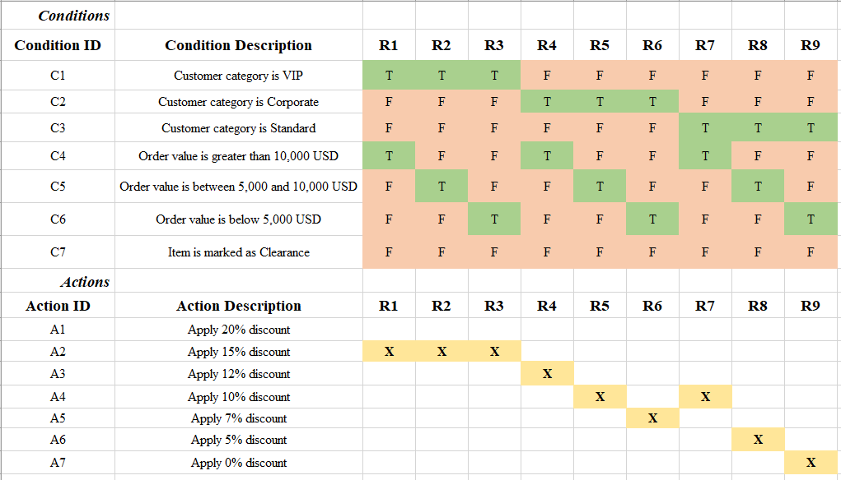
Test Case Sheet listing test cases:
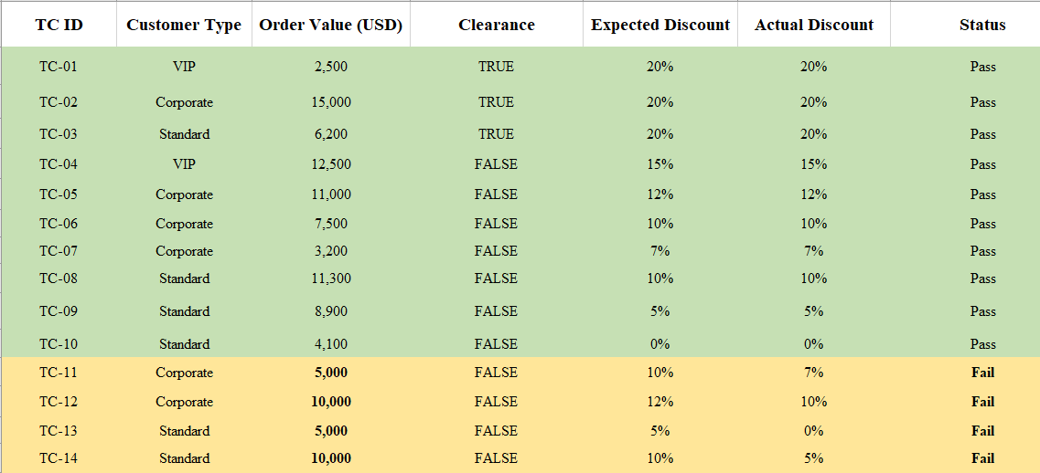

Bug Identification
The identified defects were related to incorrect handling of boundary conditions. Specifically, order values exactly equal to the boundary limits were categorized into lower discount ranges than expected.
Bug ID | Description | Test Case | Expected | Actual | Remarks
BUG-01 | Corporate order of exactly 5,000 USD treated as below 5,000 | TC-11 | 10% | 7% | Lower bound excluded
BUG-02 | Corporate order of exactly 10,000 USD treated as mid-range | TC-12 | 12% | 10% | Upper bound excluded
BUG-03 | Standard order of exactly 5,000 USD treated as below range | TC-13 | 5% | 0% | Boundary not included
BUG-04 | Standard order of exactly 10,000 USD treated as mid-range | TC-14 | 10% | 5% | Incorrect comparison
Root Cause Analysis
The root cause of all detected bugs lies in the use of strict comparison operators (>) in the discount calculation logic. These operators exclude values that are exactly equal to the boundary thresholds, causing them to fall into incorrect discount categories.
Resolution
To fix the issue, the conditional statements must include equality checks at the boundary limits. The corrected logic should use inclusive comparisons so that values equal to 5,000 USD and 10,000 USD are assigned to the appropriate discount tiers.
Example correction:
- Use >= 10000 for upper-tier discounts
- Use 5000 <= order_value < 10000 for mid-tier discounts
After applying these corrections, the discount logic was revalidated and all test cases produced the expected results.
Conclusion
This experiment demonstrates the effectiveness of Decision Table–Based Testing in validating systems that involve multiple interdependent conditions. By systematically mapping conditions to actions, decision tables simplify test design and ensure complete logical coverage. The testing process successfully identified boundary-related defects that could easily be overlooked. Once corrected, the system behaved accurately across all scenarios, confirming the reliability of the discount calculation module.

